Please ensure that you complete the application form in full as we cannot accept CVs. Please complete with black ink and block capitals. This form will be kept in confidence. Please note that no applicant will be unfairly discriminated against. This includes discrimination on account of age, cultural, religious, political beliefs, disability, ethnicity, gender, race, relationship status, sexual orientation, and / or Trade Union membership or stewardship.
If you have any special requirements to support you to complete this form (e.g. the need for large print or additional time), please contact the Registered Manager.

Position Applied For: |  |  |  |  |  |  |  |  |  |  | Location:
Work Preference: |  |  |  | Full  Time |  | Part Time |  | Bank |  | Hours Requested:
I understand this role may include: Shift work, Unsociable Hours, Lone working involved.  Yes  (Please circle your availability below) |  |  |  |  |  |  |  |  |  |  |  |  |  |  |  | No
Monday | Tuesday |  |  | Wednesday |  |  | Thursday |  |  | Friday |  |  | Saturday |  |  | Sunday
AM PM | AM PM |  |  | AM PM |  |  | AM PM |  |  | AM PM |  |  | AM PM |  |  | AM PM
Evening | Evening |  |  | Evening |  |  | Evening |  |  | Evening |  |  | Evening |  |  | Evening
 |  |  |  |  | Personal Details
First Names: |  |  |  |  |  |  |  |  | Address:
Surname:
Maiden Name:
Previous Names:
Marital Status:
Gender: |  |  |  |  |  |  |  |  | Postcode:
Place of Birth: |  |  |  |  |  |  |  |  | Nationality:
Telephone Number: |  |  |  |  |  |  |  |  | NI Number:
Mobile Number: |  |  |  |  |  |  |  |  | Email Address:
Are you a Driver: |  | Yes |  |  | No |  |  |  | Own Transport |  |  | Yes |  |  | No |  | N/A
How long have you h licence? |  | ad a |  |  |  |  |  |  | Any Endorsements: |  |  | Yes |  |  | No |  | N/A

Are you a United Kingdom (UK), European Community (EC), European Economic Area (EEA)  National | Yes | No*
*If no, please detail your current immigration status and the relevant visa currently held (including Visa number)
Are you related to any of our current members of staff or Service Users? | Yes | No
Equality Act 2010 - Under the Equality Act 2010, the definition of disability is if you have a physical or mental impairment that has a “substantial” and “long-term adverse effect” on your ability to carry out normal day-to-day activities. Further information regarding the definition of disability can be found at: www.gov.uk/definition-of-disability-under-equality-act- 2010.
Are you related to any of our current members of staff or Service Users? | Yes | No
For the purposes of this application and interview stage only, is there anything you would like us to be aware of so that we can make reasonable adjustments during the process? | Prefer not to say

Education *(All qualifications will be subject to a satisfactory check).
School / College / University | Date From: | Date To: | Examinations, Qualifications*

Training Courses attended or completing (evidence of attending courses is required)
Subject | Location | Date | Details

Pr | ofessional Memberships / Registrati |  | ons
Name of Organisation | Registration  Number | Renewal Date | Details
Employment History
Please record below the details of your full employment history beginning with your current or most recent first. Any gaps must be explained. Use a separate attached sheet if required; please sign the sheet(s)

 | Current / Most recent employer
Start Date: |  |  | End Date: |  | Salary:
Job Role: |  |  |  | Employer Name:
Reason for Leavin | g: |  |  | Contact Name:
Duties: |  |  |  | Address:
 |  |  |  | Postcode:
 |  |  |  | Telephone:
 |  |  |  | Email:

 | Employment History
Start Date: |  |  | End Date: |  | Salary:
Job Role: |  |  |  | Employer Name:
Reason for Leavin | g: |  |  | Contact Name:
Duties: |  |  |  | Address:
 |  |  |  | Postcode:
 |  |  |  | Telephone:
 |  |  |  | Email:

 |  | Employment History Continued (Copy this page if required)
Start Date: |  |  | End Date: |  | Salary:
Job Role: |  |  |  | Employer Name:
Reason for Leaving: |  |  |  | Contact Name:
Duties: |  |  |  | Address:
 |  |  |  | Postcode:
 |  |  |  | Telephone:
 |  |  |  | Email:
Start Date: |  |  | End Date: |  | Salary:
Job Role: |  |  |  | Employer Name:
Reason for Leaving: |  |  |  | Contact Name:
Duties: |  |  |  | Address:
 |  |  |  | Postcode:
 |  |  |  | Telephone:
 |  |  |  | Email:
 |  | Employment History Continued (Copy this page if required)
Start Date: |  |  | End Date: |  | Salary:
Job Role: |  |  |  | Employer Name:
Reason for Leaving: |  |  |  | Contact Name:
Duties: |  |  |  | Address:
 |  |  |  | Postcode:
 |  |  |  | Telephone:
 |  |  |  | Email:
Start Date: |  |  | End Date: |  | Salary:
Job Role: |  |  |  | Employer Name:
Reason for Leaving: |  |  |  | Contact Name:
Duties: |  |  |  | Address:
 |  |  |  | Postcode:
 |  |  |  | Telephone:
 |  |  |  | Email:

References: Please provide names, addresses and telephone numbers for referees below who we may approach for a reference.
You must provide references from your two most recent employers. In line with CQC requirements, we require references covering your last five years employment. If you have not had more than one employer in the last five years, we require a further reference. Please provide two character references if you are unable to obtain two professional references, e.g. in the case of an applicant who has been raising children for ten years. All will be contacted, therefore, please inform the referees of the fact that you have used their name. If you are unable to provide the required references, please discuss the matter with us.
 | Referee One | Referee Two
Contact Name:
Business Name:
Address:
Postcode:
Telephone:
Email:
Capacity in which known
 | Referee Three | Referee Four
Contact Name:
Business Name:
Address:
Postcode:
Telephone:
Email:
Capacity in which known
 | Additional Referee | Additional Referee
Contact Name:
Address:
Postcode:
Telephone:
Email:
Professional / Character:
Capacity in which known
Safeguarding / Ex-Offenders Declaration: Please note this section will only be seen by those involved in the recruitment process and will be treated with the strictest confidence.
The Rehabilitation of Offenders Act 1974 aims to promote equality of opportunity and is committed to treating all applicants fairly regardless of ethnicity, disability, age, gender or gender re-assignment, religion or belief, sexual orientation, pregnancy or maternity and marriage or civil partnership. Tender-hearted Limited undertakes not to discriminate unfairly against applicants on the basis of a criminal conviction or other information declared.
Answering 'yes' to the question below will not necessarily prevent your employment. This will depend on the relevance of the information you provide in respect of the nature of the position and the particular circumstances.
Are you currently bound over or do you have any current UNSPENT convictions that have been issued by a Court or Court-Martial in the United Kingdom or in any other country? |  |  | Yes* | No
Do you have any current UNSPENT police cautions, reprimands or final warnings in the United Kingdom or in any other country? |  |  | Yes* | No

Privacy Statement
We will only collect data for specified, explicit and legitimate use in relation to the recruitment process. By signing this
(We cannot estimate the exact time period, but we will consider this period over when a candidate accepts our job offer for the position for which we are considering you). When that period is over, we will either delete your data or inform you that we would like to keep it in our database for future roles.
stored by the Registered Manager and only used for the purposes of recruiting for this vacant post.
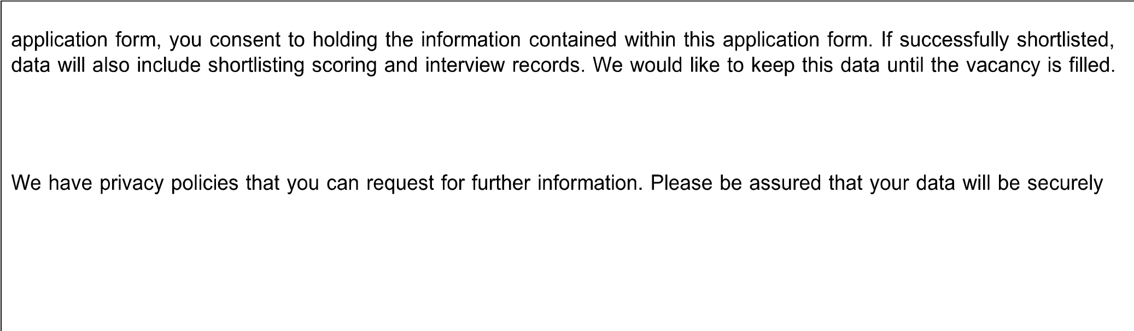
You have a right for your data to be forgotten, to rectify or access data, to restrict processing, to withdraw consent and to be kept informed about the processing of your data. If you would like to discuss this further or withdraw your consent at any time, please contact the Registered Manager to discuss.

Declaration
The information in this application form is true and complete. I agree that any deliberate omission, falsification or misrepresentation in the application form will be grounds for rejecting this application or subsequent dismissal if employed. Where applicable, I consent that can seek clarification regarding professional registration details.
Print Full Name:
Signature: |  | Date:

Supporting Statement
Please add here your reasons for applying. You should refer to the job description and person specification to guide you. It would also be of value to describe particular strengths and talents that set you apart from others as well as including skills gained from work, home and other activities.

Application Form - PR26 | Page 10/10
Values Based Screening Questions
This should be completed before attending any interview. It will be discussed as part of the interview process.
If I was a Service User, I would like:
I believe that the Service User’s family and Relatives would like the following:
I believe that I can support a Service User because:
As a member of the team, I would feel valued when:
I believe that a good relationship between me and the Service User depends upon:
I believe that I learn best when: | I believe that a good working team is made by:
I believe that my role in relation to the Service User is:
My other beliefs and values relevant to my job role are:

